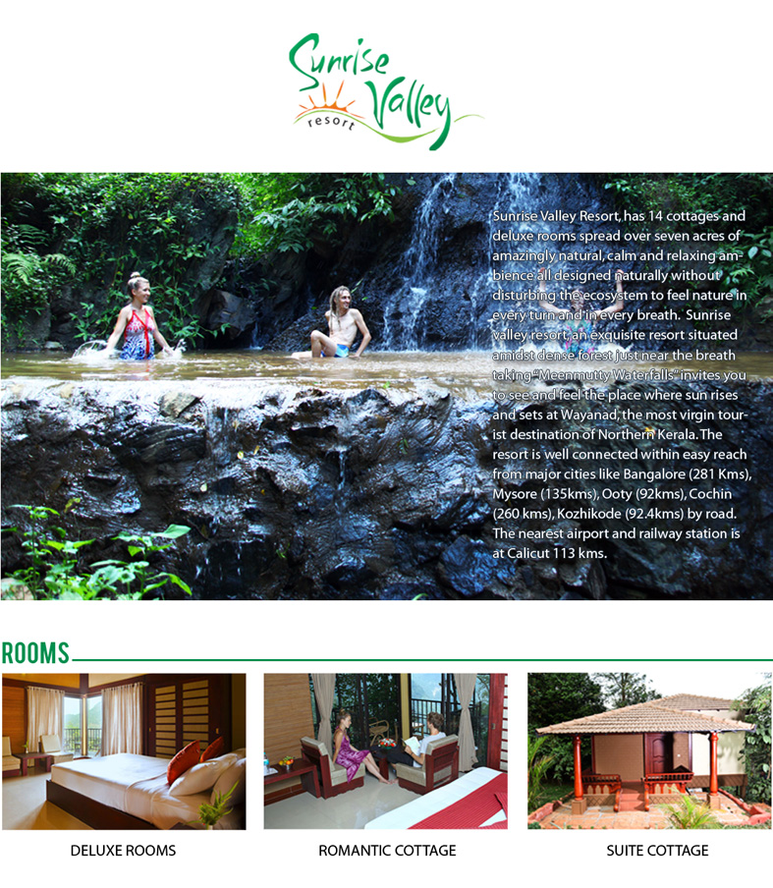
Romantic cottage
Change all the pictures and put new photos of each catogory
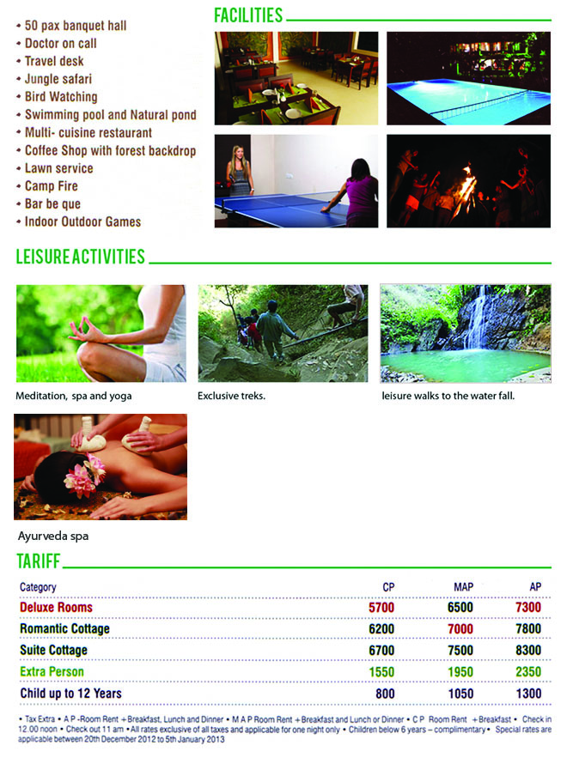
50 persons banquets facility
Remove jungle safari
